- Create a function name ADD_TWO_VALUE that accept and add two value and return the result. Test the created function using the DUAL table.

- Create a procedure raise_amount to adjust the salaries. This procedure will take in the employee ID and the raise amount (expressed as a percentage, such as .06). Based on the raise amount, the salary value in the EMPLOYEES table will be updated to the new salary. Execute the procedure to see the changes in salary column.

- Write a procedure DisplayEmployeeInfo(EmpNum) that will receive a parameter EmpNum and display the employee’s name, job, and salary in the DBMS Output like the following:

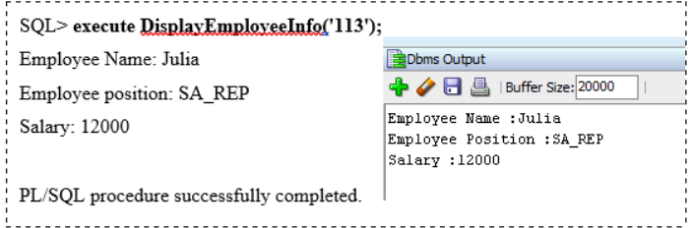

- Create a stored procedure to insert a new record into DEPARTMENTS table with the given department number and name.

- Create a trigger to audit the changes made on salary column in table Employee, keep the changes made record in table AUDIT_LOG_SALARY. The information needs to be stored in AUDIT_LOG_SALARY are old salary, new salary, employee_id, date changes and time changes. Show the steps required. Hint (1) Create the audit table (2) Create the trigger with the event after update on Employee table.

- Create a function name RETURN_TOTAL_SALARY to return the total salary based on department. The function should accept one parameter the department_id. Test the created function using the DUAL table.

